ROTOCON returns to Propak East Africa

Michael Aengenvoort, ROTOCON Group CEO, is a conference speaker on March 15

CAPE TOWN, South Africa (February 21, 2023)—ROTOCON is exhibiting for the second consecutive time at Propak East Africa, taking place March 14-16 in Kenya. On stand D21, ROTOCON will present its ECOLINE series of equipment for label printing, inspection and finishing in addition to auxiliary solutions for print production such as a plate mounter and anilox roller cleaner.
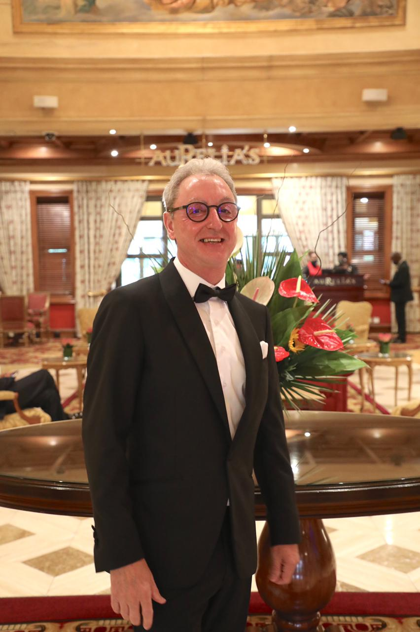
Michael Aengenvoort, ROTOCON Group CEO, is a conference speaker on March 15 at 11:00 AM where he will discuss ‘Brand building for long-term customer partnerships’.

“We are pleased to exhibit once again at Propak East Africa,” said Aengenvoort. “There is tremendous growth potential in Kenya and its neighboring countries. Our ECOLINE label finishing machines combined with solutions from our principals and our commitment to in-depth customer consultation and reliable aftersales service and technical support can help these printers compete more effectively.”
Michael Aengenvoort, ROTOCON Group CEO

Propak East Africa is at the forefront of the packaging, plastics, printing and processing industry at the largest dedicated industry exhibition in East Africa. More than 5,500 visitors, over three exciting days, join professionals from more than 35 countries.

About ROTOCON
With headquarters in Cape Town and branches in Johannesburg, Durban, Europe, and Asia, ROTOCON provides tailor-made turnkey solutions for the label printing and packaging industry. Our goal is to learn about your printing environment and recommend the ideal solution to meet your needs.

In South Africa, ROTOCON represents industry-leading brands including Cheshire Anilox Technology, Domino, DuPont, Erhardt+Leimer, EyeC, MPS, Pantec GS Systems, Phoseon Technology, Rheintacho, Rosas Maschinenbau, ROTOCONTROL, Screen, UV Ray, and Wink. Plus, ROTOCON offers a wide range of ECOLINE and CHROME printing and finishing machines.

On-site installations, training, after-sales service, maintenance, spare parts, consumables, and refurbished equipment are also available through ROTOCON.

ROTOCON is committed to providing exceptional customer service and after-sales support.

www.rotocon.world

Media Contact:

Heather Roth | Marketing Communications Manager
ROTOCON
Tel: +49 1522 181 3284
pr@rotocon.world

